training 1 epoch...

4926.100720643997 seconds used......

1 training finished! average train loss: 0.8703191137316535

total clf loss: 2107.8257530853152 total adv loss: 1354.6952699674293

evaluating...

Confusion matrix, without normalization

[[ 155 365 426]

[ 51 4760 393]

[ 33 292 7121]]

Normalized confusion matrix

[[0.16384778 0.3858351 0.45031712]

[0.00980015 0.91468101 0.07551883]

[0.00443191 0.03921569 0.9563524 ]]

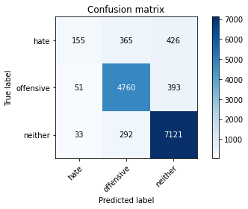

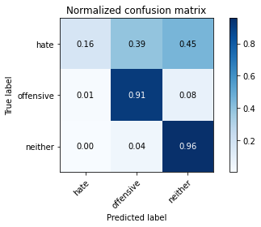

precision recall f1-score support

hate 0.65 0.16 0.26 946

offensive 0.88 0.91 0.90 5204

neither 0.90 0.96 0.93 7446

accuracy 0.89 13596

macro avg 0.81 0.68 0.69 13596

weighted avg 0.87 0.89 0.87 13596

average eval_loss: 0.3323969396105146, accuracy: 0.8852603706972639

training 2 epoch...

4927.206550121307 seconds used......

2 training finished! average train loss: 0.6999628885227652

total clf loss: 1711.9439566675574 total adv loss: 1081.1753163915128

evaluating...

Confusion matrix, without normalization

[[ 322 334 290]

[ 152 4835 217]

[ 209 469 6768]]

Normalized confusion matrix

[[0.34038055 0.35306554 0.30655391]

[0.0292083 0.92909301 0.04169869]

[0.02806876 0.06298684 0.9089444 ]]

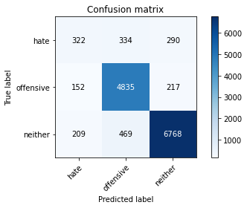

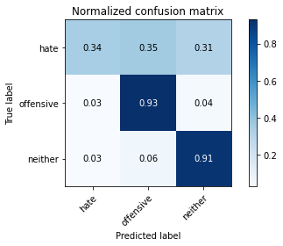

precision recall f1-score support

hate 0.47 0.34 0.40 946

offensive 0.86 0.93 0.89 5204

neither 0.93 0.91 0.92 7446

accuracy 0.88 13596

macro avg 0.75 0.73 0.74 13596

weighted avg 0.87 0.88 0.87 13596

average eval_loss: 0.34181725664940826, accuracy: 0.8770962047661077

training 3 epoch...

4925.749243974686 seconds used......

3 training finished! average train loss: 0.5625636881387304

total clf loss: 1407.297275303863 total adv loss: 853.2463697697967

evaluating...

Confusion matrix, without normalization

[[ 173 383 390]

[ 58 4820 326]

[ 34 402 7010]]

Normalized confusion matrix

[[0.18287526 0.40486258 0.41226216]

[0.01114527 0.92621061 0.06264412]

[0.00456621 0.05398872 0.94144507]]

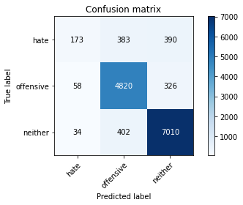

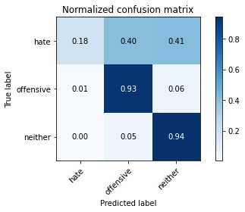

precision recall f1-score support

hate 0.65 0.18 0.29 946

offensive 0.86 0.93 0.89 5204

neither 0.91 0.94 0.92 7446

accuracy 0.88 13596

macro avg 0.81 0.68 0.70 13596

weighted avg 0.87 0.88 0.87 13596

average eval_loss: 0.35360881843987635, accuracy: 0.8828331862312445

Confusion matrix, without normalization

[[ 740 556 539]

[ 259 5234 432]

[ 630 715 9409]]

Normalized confusion matrix

[[0.40326975 0.30299728 0.29373297]

[0.04371308 0.88337553 0.07291139]

[0.05858285 0.06648689 0.87493026]]

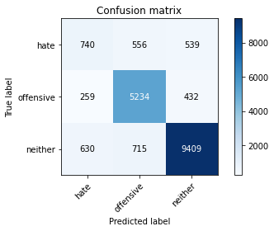

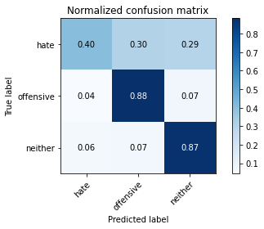

precision recall f1-score support

hate 0.45 0.40 0.43 1835

offensive 0.80 0.88 0.84 5925

neither 0.91 0.87 0.89 10754

accuracy 0.83 18514

macro avg 0.72 0.72 0.72 18514

weighted avg 0.83 0.83 0.83 18514

average eval_loss: 0.44197121896573843, accuracy: 0.8308847358755537

[25]: